Website Descriptions

Mell1Tech2

# My Story…

I had a dream, that dream was of a vision of being a **Digital** **Tradesman**, rather than a plumber turning up to your house and fixing your sink, this digital tradesman would turn up to fix your website. When talking to people about this idea they were enthusiastic about it and wanted to receive this type of service.

Digital Solutions should be built with Personal Experience

Digital Solutions should not be Over-the-counter

Digital Solutions should not charge a retainer or subscription

This means developing digital solutions to common problems people are having with websites, apps, media. I would then tailor make the solutions and hand it over to the business owner with the proper training.

The types of digital technologies I can work with:

* Websites: Wordpress, Squarespace
* App: Kotlin, Java
* Game: Unity Xamarin

The true value for business owner will be, “Complete control over the digital solution”.  
The price for a Mell1Tech2 solution will pay for itself since there are no continual expense once the solution has been developed and when handed over the business owner, they would have creative control over its direction rather than a third party.

Solutions can range from one off additions to website to a full login that requires a longer development time and even then, once developed it will be handed over to the business owner. These solutions will be independent from the web builder and only require updates when the base programming language is updated. All the documentation that went into producing the solutions will also be handed over so that any other developer can takeover.

# Inventory App

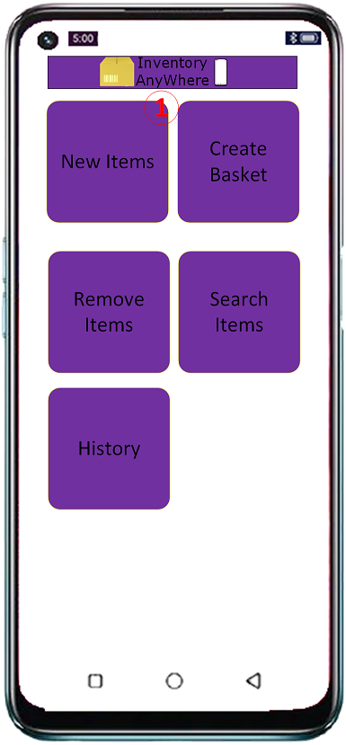The goal of this app is to solve inventory related problems in small to medium sized business, where traditional solutions are not desirable. The most common system for inventory is a POS terminal but there is an opportunity for mobile devices networked together to replace this system. Each device would serve as its own entry point into the sales system.

## The App

This Inventory App will merge a complete suite of other products. It will provide a lightweight mobile solution to inventory problems. This app can perform any task that requires scanning in items and then processing them into either a database or a spreadsheet with many options available for customising each and every screen.

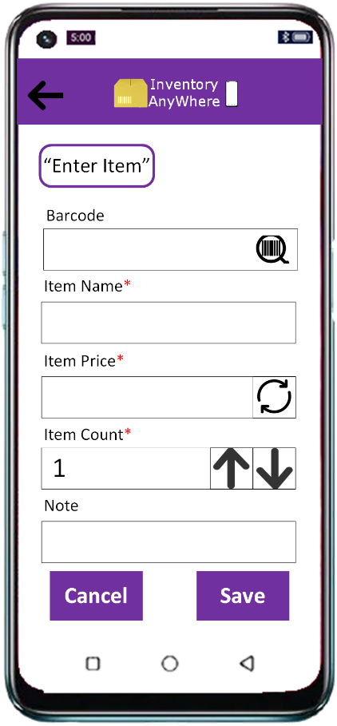

When scanning items into the app, barcoding reading and text recognition will be provided to help save time. Groups of similar products can be established so the same data can be obtained from each.

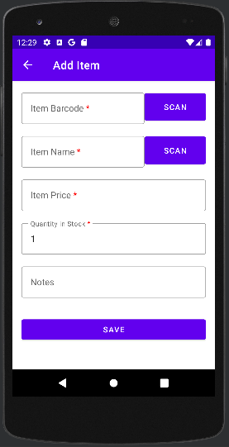What is Complete

Create/Edit Item

Scanning Barcodes

Scanning Text

Set item Price & Quantity

Add notes

Save Item to a List

Saves list to Cloud database

Button to emails List as a Spreadsheet

# Pix-a-Pix

This puzzle game was inspired by the game Minesweeper and the lesser-known Nonograms. It involves find tiles based on the hints provided as appose to minesweeper where you must avoid them. It is meant to be fast with each puzzle only taking 30 second, the puzzles are generated randomly which provides an extra challenge since no puzzle is alike.

## Why a Puzzle Game

These types of games are very simple and offer many opportunities to expand this ruleset to add an innovation while still being familiar.  
The goal is replicate the look and feel of a rhythm game with fast-paced gameplay, music, and floating icons, but I didn’t want to make a rhythm game I want to solve problems hence a puzzles game. This is the innovation present in this game, Minesweeper with a timer, a simple but powerful innovation.

## Features

* Use of high-level state machines for UI and Play loop
* The Maps are randomly created and stored in an Object
* The Object is read and used to create each tile on screen
* Each Object can even be saved as a JSON file
* The random level generation is done entirely with a mathematical formula
* A UI (plus) mirror system is the primary mechanic used for the puzzles and is incorporated into the mathematical formula
* A count (yellow box) keeps track of the number of tiles needed to complete the level